

October 30, 2020

Version 1.0

Hulk

.finance

Official

Whitepaper

Abstract 3

Introduction 4

Prologue 5

Stage 1: Presale 7

Stage 2: Staking Farms Distribution 8

Stage 3: Staking Pool 9

Stage 4: Vault 9

Governance 10

Epilogue 11

Hulk.Finance — rebranding and updates to Tokenomics and farms 12

Prologue 13

Tokenomics 14

Stage 1: Presale 15

Stage 2: Staking Farms Distribution 15

Stage 3: Staking Pool 16

Stage 4: Vault 17

Governance 18

Hulk.Finance token, its value and potential 18

[ANN] Pre-sale starts 13.10.2020 19

STAKING USDT HAS MORE STABLE PERFORMANCE THAN THE BITCOIN PRICE OVER TIME. JOIN PRE-SAIL. 20

Dear HULK.Finance community, 22

Allocations 22

Rules for Meme Contest: 23

Don’t forget to study: 23

CRYPTO HFT 25

BURNING WHEN UNSTAKING 30

REWARDS COLLECTION 30

TRANSACTION BURNING 30

Abstract

**H**

ulk.Finance is a community-governed Decentralized Autonomous Organization with four stages plan that is implementing within 90 days from project launch. We want to make DAO that will benefit from a combination of Decentralized Finance (DeFi) and High Frequency Trading (HFT). Hulk.Finance project is based on the ERC20 network and token HULK. Our brand name reminds us of medieval hulk ships that were used for storage and transportation of different values. It sounds quite good according to our vault concept.

Our project connects a high-yield partner HFT (High Frequency Trading) fund that has year-to-date yields more than 40%. The fund size is more than 70 millions USD and they operate on several cryptoexchanges like Binance and Bitmex with their API robots. What is good — automated trading does not require continuous uptrend of the Bitcoin price. We have seen good results during Bitcoin breakouts and breakdowns. Our basic idea is to connect DeFi staking pool with trading robot of the HFT fund. We will develop all infrastructure for connecting finance flows, deposits, and withdrawals.

Introduction

**Hulk.Finance** is a community-governed Decentralized Autonomous Organization with four stages plan that will be implemented within 30 days from project launch. **We want** to make DAO that will benefit from combination of Decentralized Finance (**DeFi**) and High Frequency Trading (**HFT**).

**Hulk.Finance** project is planned to be created on ERC20 network — the leading Blockchain platform. **At this stage** Hulk.Finance **is an experimental beta phase** and Hulk.Finance is based on ERC20 token **HULK.**

**Yes, we know**, that all of you are sick and tired of food token farms or DeFi scams that have been increasingly active during recent months and ended badly.

**We are different.**

Interested? Then read below.

Prologue

Do you know that big money makes big money? Do you know that big investment companies or private banking firms only with six-figures amounts? And they make them profits that are much larger than your local bank offers you (if it offers).

How do they make such profits? Credits, short and long-term investment projects, IPOs and exchange trading. The trading brings most big profits.

Nowadays there are less and less people are working in Wall Street investment companies at trading terminals. They were replaced by different trading robots, which make hundreds of trades per minute while accumulating small profits from each trade into huge amounts of money. (We recommend you to read Michael Lewis book about **High Frequency Trading (HFT)** called ‘Flash Boys’ — quite interesting.)

It has also come to crypto industry — many of you know about bots, APIs and automatic trading systems, finance pools like YFI and DFI with automatic strategy. And there are crypto funds, that also earn good APYs (**APY — annual percentage yield**) by trading on cryptoexchanges like Bitmex, Binance, Bitfinex etc.

We have a partnership with one of such cryptofunds. Current **YTD (year-to-date)** profits for stablecoins such as USDT is around 25–30%. And we want to have same profits from our investment. But there is a problem — they work with high entrance barriers of 1,000,000 USDT. We can understand it — it’s convenient to work with one client with a million, than with ten thousand clients with 100 USDT each.

What is good — automated trading does not require continuous uptrend of the Bitcoin price. We have seen good results during Bitcoin breakout and breakdowns. A sample of a real graph for 2020 is below.

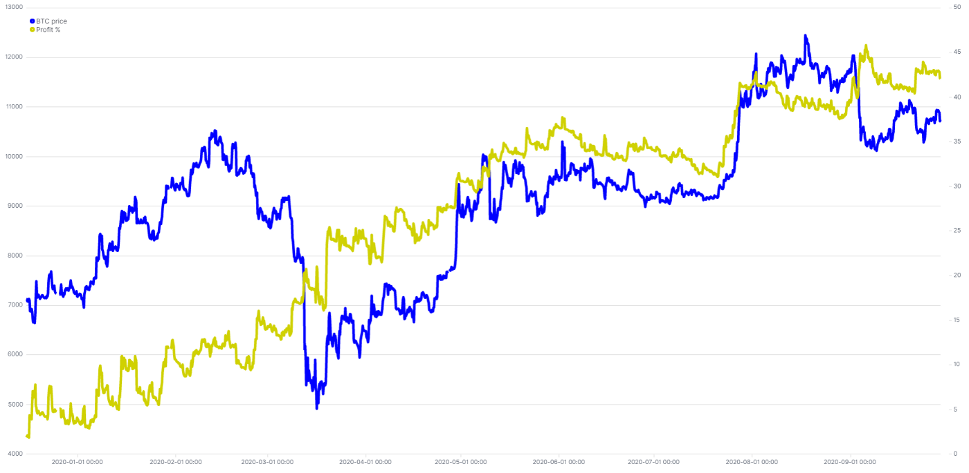

Comparison of BTC Price and YTD Yield from HTF trading

Our basic idea is make a kind of mutual fund and place it under a good and stable yield, instead of jumping from one farm to another.

**Our 4-stages roadmap includes:**

1. Presale for formation of Liquidity Pool
2. Distribution of tokens via staking farms.
3. Formation of staking pool for stablecoins.
4. Vault for token holders for sharing extra profits from HFT trading fund and other income sources.

**Hulk.Finance Tokenomics**

**Token Symbol: HULK**

**Token Purpose:** governance token with profit sharing model

**Token Supply:** 100,000

**Presale Amount:** 10,000

**Initial Liquidity Pool Part:** 10,000

**Farms Distribution:** 80,000

**Seed Round** **Presale Price**: 0.1 ETH

Team and Developers part will be equal to **6%** from farmed HULKs (4,800 HULKs), and will be locked for 3 months after the end of farming, and unlock linearly during 12 months.

Stage 1: Presale

We will premine 20,000 HULKs initially: 10,000 HULKs will be sold during presale round, and another 10,000 HULKs will be added to the Liquidity Pool together with funds from Presale.

So we expect to have a Liquidity Pool on Uniswap with 10,000 HULKs and at least 950 ETHs prior to the beginning of farming pools. The Liquidity Pool will be locked for 12 months to exclude any rug pulls.

***Seed Round****:*

Strategic investment from individuals for formation of a part of initial Liqudity Pool, the sale amount: 10,000 HULKs. The minimum bid amount 1 ETH. Maximum amount 25 ETH. The seed round price 1 HULK= 0.1 ETH. Link and dates of seed round are to be announced later.

All unsold HULKs will be burned by sending to a burn address. Equal amount of HULKs will be burned from the Initial Liquidity Pool Part.

95% of ETH funds collected during two presale rounds will be sent to newly created Uniswap Pool HULK-ETH together with the appropriate amount of minted HULKs. The Liquidity Pool will be locked for 12 months.

5% of ETH funds collected will be used for marketing and SMM activities and also for vault and voting system development. All financial reports will be published on our Medium. Links and tx hashes will be posted on Telegram and Twitter.

Stage 2: Staking Farms Distribution

In order to attract attention of DeFi world to our project and for **fair distribution** of tokens we will run staking farms for farming 80,000 HULKs. You will need to stake appropriate tokens in selected farm to get your share of rewards in HULKs.

Farm 1 will farm rewards of 60,000 HULKs within 15 days, staking token — ETH-HULK LP Uniswap V2.

Farm 2 will farm rewards of 10,000 HULKs within 15 days, staking token — *Token X* .

Farm 3 will farm rewards of 10,000 HULKs within 15 days, staking token — *Token Y* .

*Token X* and *Token Y* are to be decided by our community.

Farming period for all three farms will be 15 days.

We implement halving each three days, so early farmers will get more HULKs.

Planned token distribution by staking farms

The hourly reward will be equal to your share of staking pool multiplied by the hourly reward.

Hourly reward in Farm 1 on day 1 will be equal 10322,58/24 = 430,10 HULKs per farm, on day 12 — 1290,32/24=53,76 HULKs per farm.

If there are 100,000 TokenX staked in Farm 2 and you stake 1,000 TokenX — your pool share will be 1%.

APY will be high during the first few days of farming and then will start to decrease.

After 15 days of farming no more new HULKs will be minted or issued.

You may want to sell it via Uniswap but we suggest to hold on to them to get your share of profits from Stage 4 (read below).

Stage 3: Staking Pool

Due to HFT fund terms and conditions we have developed the following conditions for USDT staking pool 1.

We will launch staking pool for USDT tokens at first. Later, after voting of HULKs holders we may select which stablecoin pools to add and at what sizes and APY rates.

Staking pool will be open for everyone on following terms and conditions.

**Staking Pool 1 Limit**: 10 million USDT.

**APY**: 14%.

**Minimum Staking Amount** : 100 USDT.

**Type Of Staking**: Locked

**Minimum Staking Term**: 24 hours

**Withdraw Period**: 24 hours after withdraw order.

**Reward Calculation:** daily.

Funds from the staking pool will be transferred to HFT fund for trading operations.

Stage 4: Vault

HFT fund will send profits from its operation once a month, on the first day of the following month.

HULK holders may hold their HULK tokens in their wallet, in Uniswap Liquidity Pool or in HULK vault.

Monthly profit from HFT operations will be shared between HULK tokens staked in vault according to the time of staking divided on 720 hours.

***Example****:*

*You stake your 500 HULK tokens in Vault for 20 days (480 hours). Your HULK/hours equal to 500*480=240,000.*

*Total HULK/hours in Vault in this month — 60,000,000. Your share in this month = 0,4%.*

*HFT funds earned 3% on staking pool funds in this month. After payout of their 1% per month to USDT stakers, the remaining part is 10,000,000 USDT x 2% 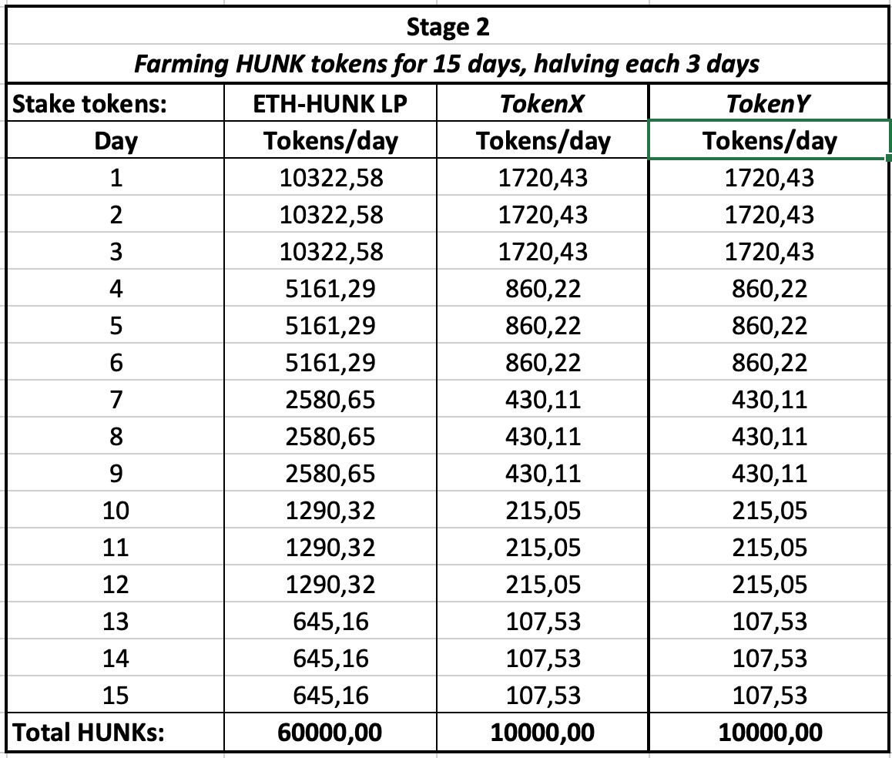= 200,000 USD.*

Your share in profits — 0.4% of 200,000 = 800 USDT.

Governance

We want to be a **Decentralized Autonomous Organization (DAO)**, and we want the holders of HULK tokens to participate in key project decisions, like selection of new investment tools, project roadmap changes, new staking pools formation, their terms and conditions etc.

For this reason we will implement a voting system for HULK holders that will be ready within 30 days after project launch. Following the implementation, HULK holders will be able to make proposals for voting.

Epilogue

Thank you for your attention while reading. Feel free to contact us in Telegram groups or on Twitter, we appreciate any advice or suggestions. Also ‘spreading the word’ is always welcome. Thank you for sharing.

[https://twitter.com/HulkFinance](https://twitter.com/HunkFinance)

<https://discord.gg/qGmvwKH>

P.S. We are group of crypto enthusiasts and early DeFi adopters. We are based in different countries of Europe, because we are decentralized.

P.P.S. “*Decentralize”* © [Kanye West](https://twitter.com/kanyewest/status/989184815340535808?s=20).

P.P.P.S. *“You built a factory and it turned into something terrific or a great idea, God bless. Keep a big hunk of it. But part of the underlying social contract is you take a hunk of that and pay forward for the next kid who comes along.”* © *[Elisabeth Warren](https://www.brainyquote.com/quotes/elizabeth_warren_417043)*

P.P.P.P.S. In the first edition of this article our project had a name ‘Hunk.Finance’, where Hunk had a meaning of a large piece or portion. Later we have changed the name to Hulk, which means not only green superhero, but a hulk ship, that protects your treasure.

Hulk.Finance — rebranding and updates to Tokenomics and farms

As you may already know, we have rebranded our project from Hunk.Finance to Hulk.Finance.

Our brand name reminds us of medieval hulk ships, that were used for storage and transportation of different values. So it sounds quite good according to our vault concept.

From another point of view, we love this famous green superhero and we want to believe that our project will be as strong and huge as Hulk. And we also respect our vegan followers that don’t like the previous meat hunks logo. Now we are ***greener***.

We want to assure you, that our main principle has not changed. Hulk.Finance is a community-governed **Decentralized Autonomous Organization** with four stages plan that is implementing within 90 days from project launch. We want to make DAO that will benefit from a combination of Decentralized Finance (**DeFi**) and High Frequency Trading (**HFT**).

Hulk.Finance project is based on the ERC20 network and token **HULK**.

Prologue

Basic inputs to our project are explained in this [article,](https://medium.com/@hulkfinance/hunk-finance-combining-decentralized-finance-defi-and-high-frequency-trading-hft-fffdf507d5a8?source=---------2----------------------------) so just a short reminder below.

Our project connects high-yield partner HFT (High Frequency Trading) fund that successfully works from the beginning of 2020 and has year-to-date yields more than 40%. The fund size is more than 70 millions USD and they operate on several cryptoexchanges like Binance and Bithumb with their API robots. What is good — automated trading does not require continuous uptrend of the Bitcoin price. We have seen good results during Bitcoin breakouts and breakdowns.

HTF YTD Yield and Bitcoin price in 2020

We want to have the same yields from our investments. But there is a problem — they work with an entrance barrier of 1,000,000 USDT, like many private banking services or high-yield ETFs.  
Our basic idea is to make a kind of DeFi staking pool and put it under the management of the HFT fund. We will develop all infrastructure for connecting finance flows, deposits, and withdraws.

**Our 4-stages roadmap includes:**

1. Presale for formation of Liquidity Pool on Uniswap
2. Distribution of tokens via staking farms.
3. Formation of staking pool for stablecoins.
4. Vault for token holders for sharing extra profits from HFT trading fund and other income sources.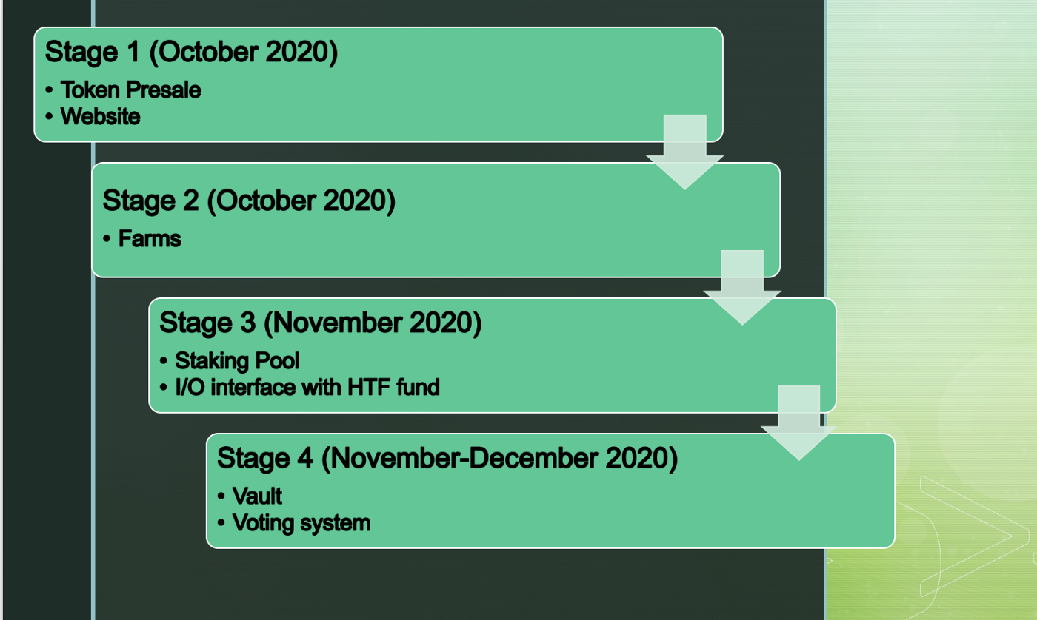

Project roadmap

Tokenomics

**Token:** **HULK**  
**Total Supply**: 100,000 (20,000 are initially minted, 80,000 will be minted during Farms distribution)  
**Marketing (airdrops and other perks)**: 1,000 + 10% of ETH funds collected during pre-sale  
**Development part:** 1000 + 10% of ETH funds collected during pre-sale  
**Private sale:** 5000 (including bonuses)  
**Public Pre-sale:** 5000  
**Initial Liquidity Pool Part:** 8,000 + 80% of ETH funds collected.  
**Farms Distribution:** 80,000 (inc. Team Part 6%, or 4,800 tokens)  
**Seed Round Pre-sale Price:** 0.1 ETH

Team Part will be equal to 6% of HULKs farmed during the farms’ distribution stage (4,800 HULKs), and will be locked for 3 months after the end of farming, and unlock linearly during 12 months.

In order to support the token price from dumping, we plan to take a 5% commission from the token seller, if a sale takes place on Uniswap. This 5% commission will be split and sent to a burn address (4%) and to community grants address (1%). 4% from the burn address will be minted via farms later. Community grants will be put into marketing during the token lifecycle.

Stage 1: Presale

We will mint 20,000 HULKs initially.

1,000 HULKs will be used for marketing purposes **before and during** the presale stage.

Presale will take place on the Bounce platform. The minimum bid amount 1 ETH. Maximum amount — 35 ETH. The seed round price 1 HULK= 0.1 ETH.

10,000 HULKs will be distributed during the presale round. All unsold HULKs will be burned. 8**0%** of ETH funds received will be added to Liquidity Pool.

10% of collected funds will be used for the development of the vault and the voting system. The remaining **10%** will be used for marketing and SMM activities **after** presale stage and also for vault and voting system development.

The amount of 8,000 HULKs or less will be added for the formation of a locked Liquidity Pool on Uniswap.

All financial reports will be published online.

Stage 2: Staking Farms Distribution

For the purpose of **fair distribution** of tokens, we will run staking farms for farming 80,000 HULKs. You will need to stake appropriate tokens on the selected farms to get your share of rewards in HULKs.  
Farm 1 will farm rewards of 60,000 HULKs within 15 days, staking token — ETH-HULK LP Uniswap V2.  
Farm 2 will farm rewards of 10,000 HULKs within 15 days, staking token — Token X.  
Farm 3 will farm rewards of 10,000 HULKs within 15 days, staking token — Token Y.  
**Token X and Token Y will be announced prior to the farms’ launch.**  
Genesis farming time will be 15 days, after that farming rate will be settled on the level of 15th day.  
We implement halving every three days, so early farmers will get more HULKs.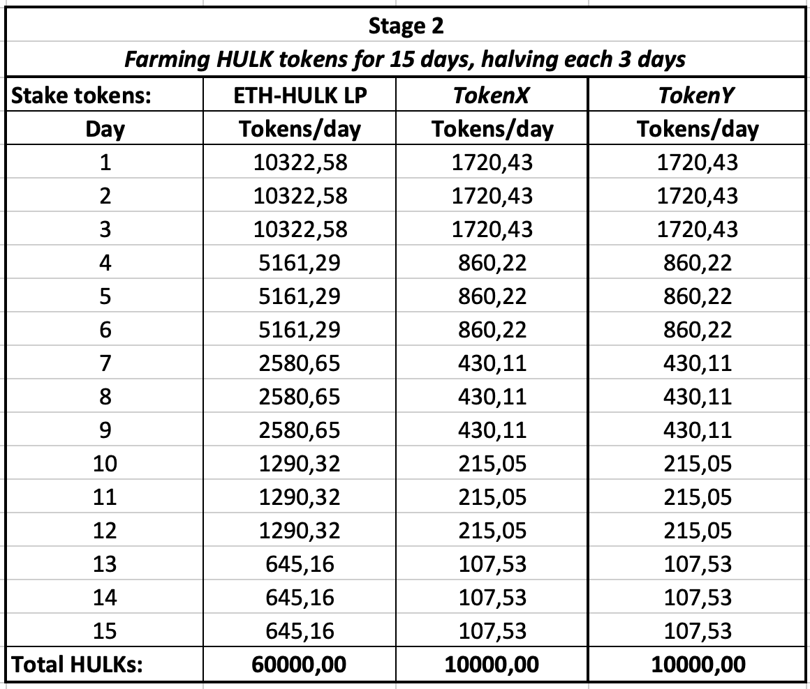

Planned HULKs distribution

***Farming Stage Update*:** In order to support the price of the token from dumping, we will take **a 5% commission** for the sale of tokens, when holders sell it on Uniswap, **burn 4% and add 1%** to the community grants account. The burnt amount will be added to farming pools after 15 days of initial farming. So, for example, if someone sold 20,000 HULKs, we will take 1,000 tokens, burn 800 of them and they will be re-minted on day 16. 200 tokens will be sent to the community grants address. The total supply is 100,000 tokens.

Stage 3: Staking Pool

Due to HFT fund terms and conditions, we have developed the following conditions for USDT Staking Pool 1.  
The staking pool will be open for everyone on the following terms and conditions.  
**Staking Pool 1 Target:** 10 million USDT.  
**Guaranteed APY:** 15%.  
**Minimum Staking Amount:** 100 USDT.  
**Type Of Staking:** Locked  
**Minimum Staking Term:** 24 hours  
**Withdraw Period:** 24 hours after withdrawal order.  
**Reward Calculation:** daily.  
Funds from the staking pool will be transferred to the HFT fund for trading operations.

Stage 4: Vault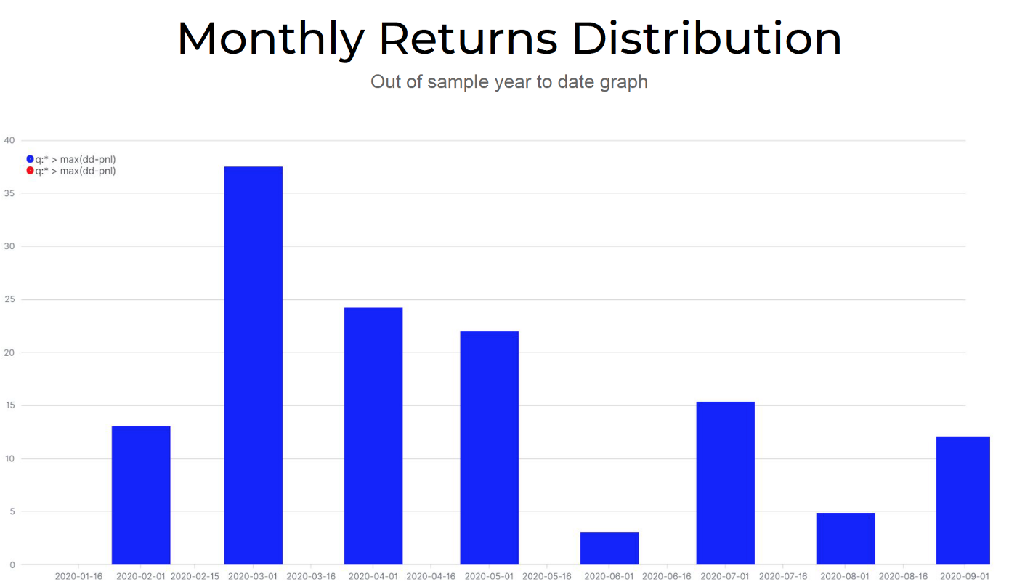

Current Monthly Returns Distribution of one of HFT strategies

We want to share revenue from HFT fund among HULK holders, that stake their tokens in HULK Vault.  
HFT fund will send revenue from its operation once a month, on the first day of the following month.  
**Current concept:** Monthly revenue from HFT operations will be shared between HULK tokens staked in the vault according to the time of staking divided on 720 hours.

***Example****:  
You stake your 500 HULK tokens in Vault for 20 days (480 hours). Your HULK/hours equal to 500*480=240,000.  
Total HULK/hours in Vault in this month — 60,000,000. Your share in this month = 0,4%.  
HFT fund has earned 4% on staking pool funds in this month. After payout of their 1,25% (15%/12) per month to USDT stakers, the remaining part is 10,000,000 USDT x 2,75% = 275,000 USD.  
Your profit share 0.4% of 275,000 = 1100 USDT will be sent as USDT to your address, connected with a Vault.*

Governance

As the DAO we want the holders of HULK tokens to participate in key project decisions, like the selection of new investment tools, project roadmap changes, new staking pools formation, their terms, and conditions, etc.  
For this reason, we will implement **a voting system** for HULK holders that will be ready within 30 days after the project launch.

Hulk.Finance token, its value and potential

We will run a presale of HULK tokens in a few days. As we wrote before, we plan to sell 10,000 HULKs at a presale price of 0.1 ETH (or 1 ETH=10 HULKs)

Currently, our community votes in a Twitter poll, what maximum presale allocation per one wallet should be. The battle between 15 and 35 ETH limits is a real intrigue.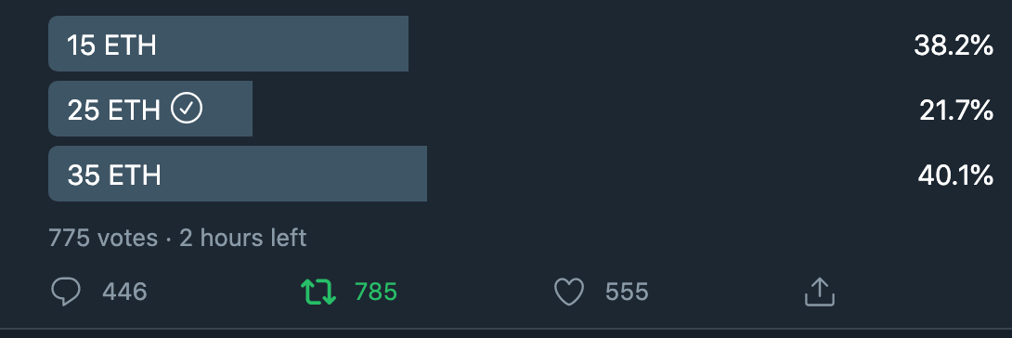

Meanwhile, let us remind you, what value HULK token bears. It is a profit-sharing token, so each holder of HULK token will get an appropriate profit share from the monthly earnings of our staking pool under HFT fund management.

What is the target profit estimate that we expect to have? We have two variants based on current statistics of HFT fund: Conservative — APY 25% and Optimistic — APY 40%.

Let’s assume that we are running just one staking pool #1 — USDT. We have a very good guaranteed interest rate of 15%, and we have reached our target cap of 10,000,000 USDT due to it.

Conservative scenario: HFT fund brings our DAO 25% APY, which is equal to 2,500,000 USDT. We have to pay out 1,500,000 to our USDT stakers, and we have 1,000,000 to be distributed between our HULK Vault stakers. Let’s assume that all 100,000 HULKs are staked 100% time in Vault. So we have to distribute 1,000,000 between 100,000 token holders. It is 10 USDT/per 1 token. In practice, we expect that 70% of tokens will be staked, others will circulate on market.

In the Optimistic scenario, the HFT fund brings 40% APY from trading operations to our DAO, which is equal to 4,000,000, and after the payout, HULK holders have 2,500,000 to split. It is 25 USDT/per 1 token.

In other words, earnings may vary from 10 to 25 USDT per token.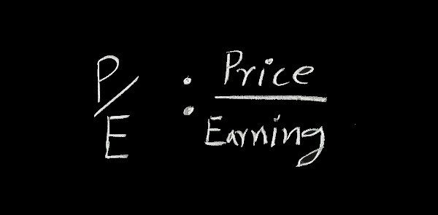

The average P/E (Price/Earnings ratio) for the S&P 500 has historically ranged from 13 to 15. If we were based on traditional market averages and planned earnings are 10 USDT, the price of the token should vary from 130 to 150 USDT, in optimistic cases, it may reach 325–375 USDT.

In the crypto world, P/E ratios are different. For example, there are calculations for in this article, and Maker token P/E is equal to 249,66 and Synthetix- 120,52. We think that such P/E is a bit unreal, but who knows. And you may estimate the token price by yourself.

We believe that the combination of our ideas and the quality of development will bring us to set targets. And we remind you once again, that we are DAO — Decentralized Autonomous Organization. So you may join our ride very soon, during our presale, with a special price 0,1 ETH per 1 HULK token.

Subscribe to our Telegram and Twitter not to miss the launch of the presale, only 10 000 HULKs will be sold.

Also, we plan a small airdrop for early followers, stay tuned.

[ANN] Pre-sale starts 13.10.2020

We are pleased to announce the start of HULK tokens pre-sale.  
  
**!!! OUR CONTRACT IS NOT YET ON UNISWAP !!!**

**Our verified contract address is here —** <https://etherscan.io/address/0xe1f8cd01ab04b51d02c6fb2bca61b03fb5e33b99#code>

**Pre-sale will take place on** <https://app.bounce.finance/fixed-swap/3647> **as a fixed swap contract today, 13.10.2020 at 12:00 GMT.**

All information with correct swap link will be published at 12:00 GMT 13.10.2020 on our website <https://hulk.finance/> and social networks:  
<http://t.me/Hulkfinance>  
<https://medium.com/@HULKfinance>  
<https://twitter.com/HULKfinance>  
<https://discord.gg/qGmvwKH>

Please, double check swap link and contract address before participation in pre-sale.

STAKING USDT HAS MORE STABLE PERFORMANCE THAN THE BITCOIN PRICE OVER TIME. JOIN PRE-SAIL.

Our project connects DeFi with a high-yield partner HFT (High Frequency Trading) fund that successfully works from the beginning of 2020 and has year-to-date yields more than 40%. The fund size is more than 70 millions USD and they operate on several cryptoexchanges like Binance and Bithumb with their API robots. What is good — automated trading does not require continuous uptrend of the Bitcoin price.

Hulk.Finance is a community-governed Decentralized Autonomous Organization with four stages plan that is implementing within 90 days from project launch. We want to make DAO that will benefit from a combination of Decentralized Finance (DeFi) and High Frequency Trading (HFT).

**Tokenomics**:  
Token: HULK  
Total Supply: 100,000 (20,000 are initially minted, 80,000 will be minted during Farms distribution)  
Marketing (airdrops and other perks): 1,000 + 10% of ETH funds collected during pre-sale  
Development part: 1000 + 10% of ETH funds collected during pre-sale  
Private sale: 5000 (including bonuses)  
Public Pre-sale: 5000  
Initial Liquidity Pool Part: 8,000   
Farms Distribution: 80,000 (inc. Team Part 6%, or 4,800 tokens)  
Seed Round Pre-sale Price: 0.1 ETH

Pre-sale will last 10 days or till hard cap is reached.

**Private bonus sale rounds**:

**First comes — First takes.**  
Round 1: 200 HULK × 0.1 ETH × **5x bonus** (pay for 1, get 5, hard cap 20 ETH) — **SOLD!**  
Round 2: 250 HULK × 0.1 ETH × **4x bonus** (pay for 1, get 4, hard cap 25 ETH)  
Round 3: 333 HULK × 0.1 ETH × **3x bonus** (pay for 1, get 3, hard cap 33.3 ETH)  
Round 4: 500 HULK × 0.1 ETH × **2x bonus** (pay for 1, get 2, hard cap 50 ETH)  
Round 5: 666 HULK × 0.1 ETH × **1.5x bonus** (pay for 1, get 1.5, hard cap 66.6 ETH)  
The next round is automatically activated when hard cap of the round is reached. Bonus tokens will be credited after listing on Uniswap.

**Public Pre-sale (NO BONUSES):**

Round 6: 5000 HULK × 0.1 ETH (hard cap 500 ETH)

Pre-sale information:  
Pre-sale will be on [bounce.finance](http://bounce.finance/) with a hard cap 694.9 ETH. The minimum pre-sale purchase is at least 1ETH, the maximum is 35 ETH. All unsold tokens will be burned.

Uniswap listing will be made after pre-sale finishes. We will have locked Liquidity Pool.  
***Don’t miss this opportunity to join HULK token holders team.***

***sd***

Start presale

**!!! OUR CONTRACT IS NOT YET ON UNISWAP !!!**

**Our verified contract address is here —** <https://etherscan.io/address/0xe1f8cd01ab04b51d02c6fb2bca61b03fb5e33b99#code>

**Pre-sale IS GOING on** <https://app.bounce.finance/fixed-swap/3647> **as a fixed swap contract today, started 13.10.2020 at 12:00 GMT.**

Seed Round Pre-sale Price: 0.1 ETH

Pre-sale will last 10 days or till hard cap is reached.

**Private bonus sale rounds**:

**First comes — First takes.**  
Round 1: 200 HULK × 0.1 ETH × **5x bonus** (pay for 1, get 5, hard cap 20 ETH) — **SOLD**  
Round 2: 250 HULK × 0.1 ETH × **4x bonus** (pay for 1, get 4, hard cap 25 ETH) — **SOLD**  
Round 3: 333 HULK × 0.1 ETH × **3x bonus** (pay for 1, get 3, hard cap 33.3 ETH)  
Round 4: 500 HULK × 0.1 ETH × **2x bonus** (pay for 1, get 2, hard cap 50 ETH)  
Round 5: 666 HULK × 0.1 ETH × **1.5x bonus** (pay for 1, get 1.5, hard cap 66.6 ETH)  
The next round is automatically activated when hard cap of the round is reached. **Bonus tokens will be credited after listing on Uniswap.**

**Public Pre-sale (NO BONUSES):**

Round 6: 5000 HULK × 0.1 ETH (hard cap 500 ETH)

Dear HULK.Finance community,

our team has decided to create a fun moment for all of us, and allow our community to express their best skills for a possibility to get a share of the 6 ETH pool in #HULK tokens! The contest will run for one week starting from 14/10/2020 12:00–21/10/2020 18:00 UTC.

3 winners in [Twitter](https://twitter.com/HulkFinance/status/1316409288303226881?s=20) and 3 winners in Telegram will be announced, with a total prize fund of 60 HULK (equivalent to 6 ETH)

Allocations

Twitter Prize Fund:

1rd place — 15 💲HULK

2nd place — 10 💲HULK

3rd place — 5 💲HULK

Telegram Prize Fund:

1rd place — 15 💲HULK

2nd place — 10 💲HULK

3rd place — 5 💲HULK

The Hulk team will choose YOUR best image/meme about Hulk.finance. From simple designs created with the meme generator to your own made with Photoshop. Gifs are welcome!

Rules for Meme Contest:

🔸Memes MUST contain the Hulk.finance logo or text “Hulk.finance” or “Hulk”

🔸Subscription to Telegram chat is required <http://t.me/Hulkfinance>

🔸Your works must be sent to [Telegram chat](http://t.me/Hulkfinance), or [Twitter post](https://twitter.com/HulkFinance/status/1316409288303226881?s=20) comments with the hashtag #hulkmemecontest

🔸The competition will last 1 week (ends on 21.10.20), multiple applications are allowed, but only one application per person can receive a prize. The more high-quality and funny memes, the more chances to win.

Don’t forget to study:

<https://en.m.wikipedia.org/wiki/Hulk_(ship_type)>

and HULK from Marvel is also welcome, especially in this pre-Halloween period.

Good Luck!

PARTNERSHIP WITH TON COMMUNITY

Many of you have heard about Telegram Open Network, but do you know that it is not ended? There is a big TONCommunity.org (<https://toncommunity.org/>) that relaunches TON network now, has a clear vision and developed roadmap for launching TON blockchain.

As a sign of respect and in order to support these efforts we have decided to add one more application of TON tokens — we are going to use it as a staking token in our farm #2.

As you know, [our pre-sale rounds](https://medium.com/@hulkfinance/hulk-pre-sale-has-started-4879e2322e96) are going now and we have successfully capped two bonus rounds already. After pre-sale end we will make Liquidity Pool on Uniswap and launch Farms Distribution Stage.

We are proud to announce the selection of TON/ETH LP token as a staking token for our farm #2. Farm launch is planned on 23.10.2020 at 13:00 GMT/UTC.

We will have 3 farms:

Farm 1: HULK/ETH LP UNI-V2 Token, Distribution: 60,000 HULKs in 15 days.

Farm 2: [TON](https://etherscan.io/token/0x6a6c2ada3ce053561c2fbc3ee211f23d9b8c520a)/[ETH](http://0xc02aaa39b223fe8d0a0e5c4f27ead9083c756cc2/) LP UNI-V2 Token, Distribution: 10,000 HULKs in 15 days.

Farm 3: To be announced soon — codename Token Y

Please, don’t forget — **HULK is not listed on UNISWAP.**

Farms distribution table

CRYPTO HFT

We have received many questions about our difference from other DeFi projects. In this post, we will try to explain it in more detail.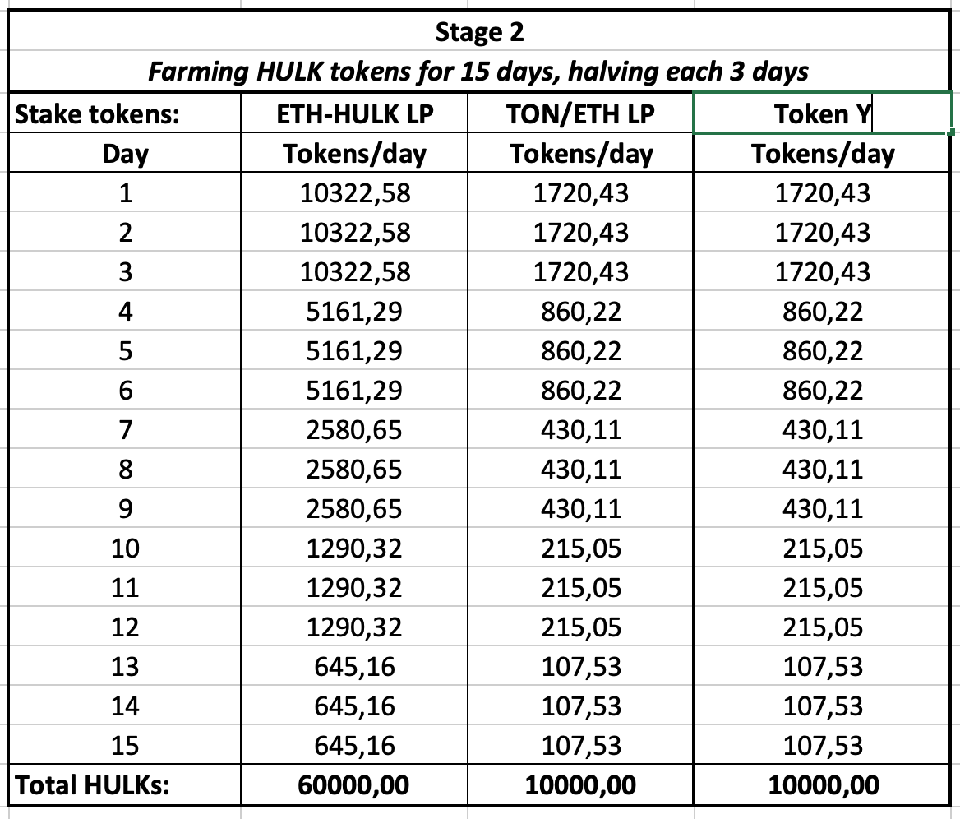

Of course, all of us have come to crypto for technology. Just kidding. Reason #1 is to improve your wealth position and to increase numbers on your accounts.

The evolving crypto market provides many new opportunities daily. Many of you remember different hypes, like cloud mining, masternodes, Cryptokitties collectibles, decentralized finances (DeFi). Uniswap has become the main innovation of this year. DeFi farms and lending platforms are very popular now.

You may use these opportunities trying to increase your crypto position, but sometimes you win, sometimes you fail.

One of our main goals of our community is an organization of community members access to high-frequency trading algorithms.

High-frequency trading, also known as HFT, is a method of trading that uses powerful computer programs to transact a large number of orders in fractions of a second. It uses complex algorithms to analyze multiple markets and execute orders based on market conditions. Typically, the traders with the fastest execution speeds are more profitable than traders with slower execution speeds.

In addition to the high speed of orders, high-frequency trading is also characterized by high turnover rates and order-to-trade ratios.   
With millions of transactions per day, this results in a large amount of profits, like a real Money Machine.

We have a partner crypto trading fund, that has developed HFT algorithms and tailored different strategies aimed at generating profits in fiat or bitcoins. They use a set of 50 separate algorithms for trading, which are selected from 12000 backtested strategies.

After development, each strategy was tested on historical data, then beta-tested with a small amount of own funds, and after that went live with investment assets.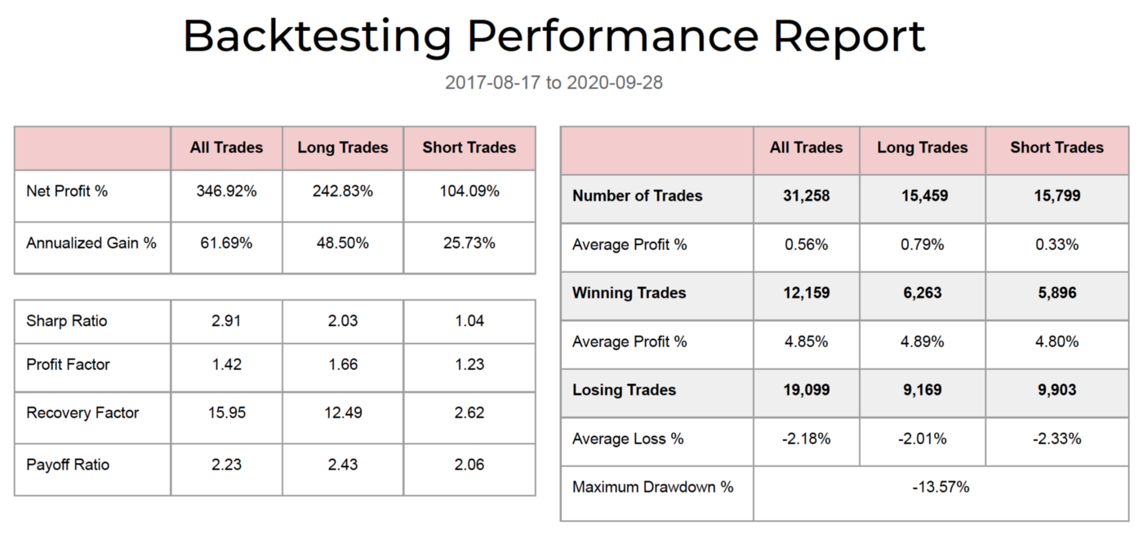

Backtesting performances rapports

The Fund’s HFT algorithms have demonstrated stable positive gains in monthly and quarterly periods.

Returns distribution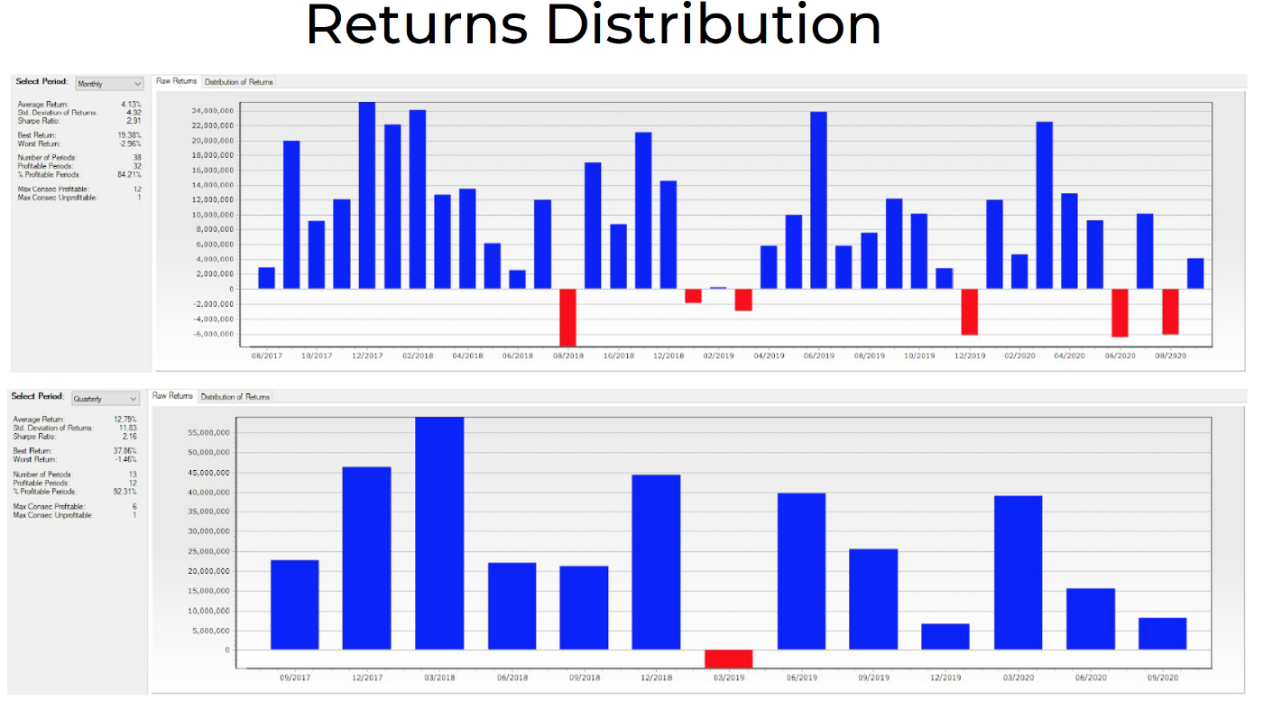

Starting from January 2020 the Fund has started a money management service, providing HFT algorithmic trading on clients’ funds on Bitmex and Binance exchanges. The Fund takes money management fees based on the amount of investment and gained profits. The Funds provides service for rich clients with high entrance barrier and its current volume exceeds 70,000,000 USD.



The result is very impressive, for example, a set of strategies for generating profits in fiat demonstrated high profits even during Bitcoin drawdown.

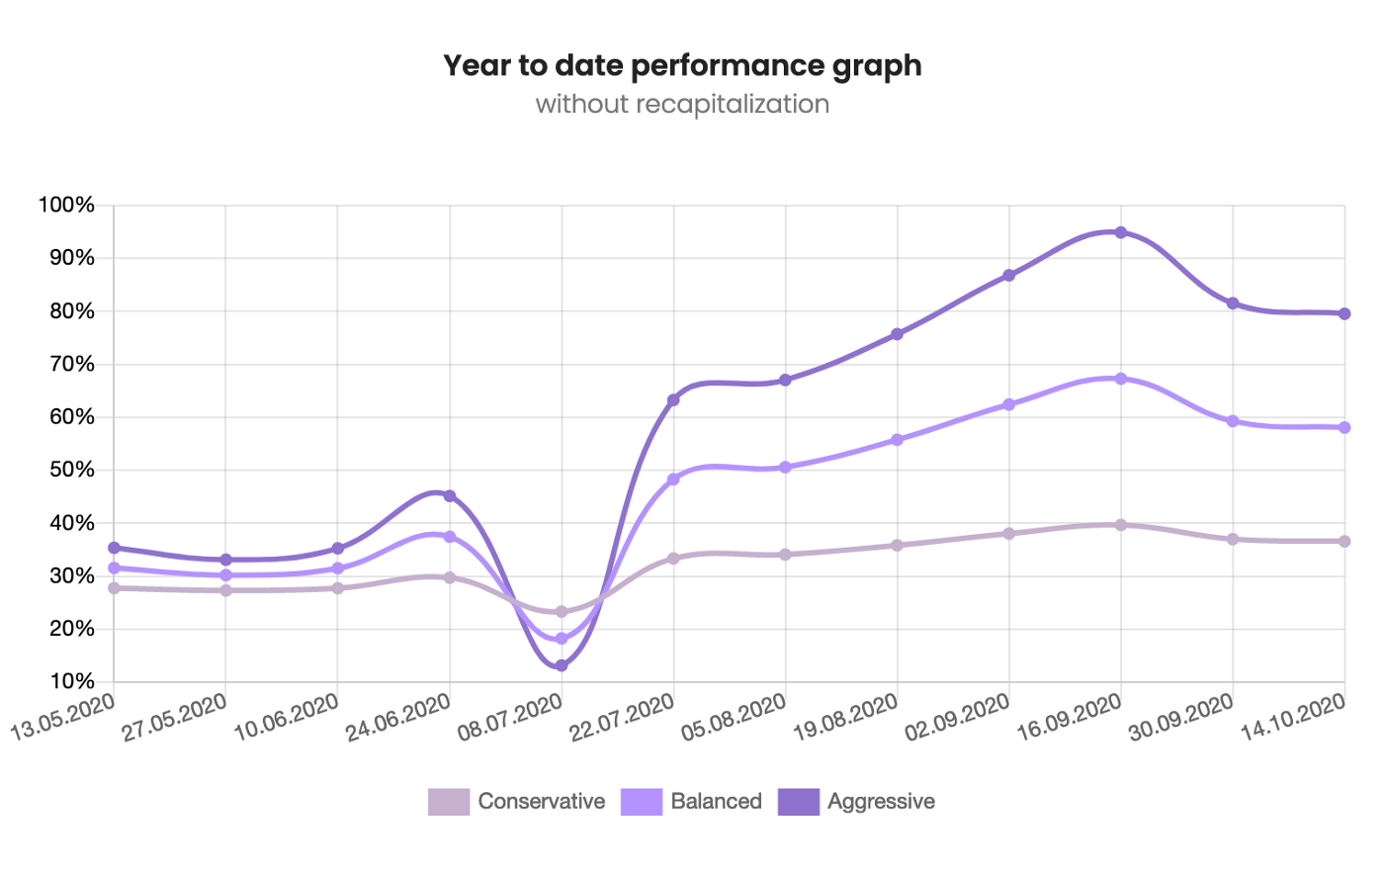

Performance graph

The purpose of Hulk.Finance project is to make these HFT algorithms available for the mass market. We are developing the contract, that will allow to deposit and withdraw funds on a dedicated trading account, which will be managed by HFT trading API. The achieved results allow us to guarantee a stable fixed income on USDT deposits in a locked staking pool.

Due to the necessity of trading positions closure, the staking pool will have a minimal lock and withdrawal period of 24 hours. Preliminary APY for staking pool #1 is 15%.

**All profits above this APY will be distributed between HULK tokens holders once a month in the form of USDT transfers.**

You may purchase HULK tokens during pre-sale, which is going now on <https://app.bounce.finance/fixed-swap/3647>.

The Uniswap listing and Farms distribution stage is planned for 23.10.2020.

Stay tuned for the announcement.

UNISWAP LISTING TOKENS BURN

Our bonus presale is over. We have distributed bonus tokens and burnt unsold tokens.

Smart contract Address: <https://etherscan.io/token/0xe1f8cd01ab04b51d02c6fb2bca61b03fb5e33b99>

We have received first audit report:  
<https://solidity.finance/audits/Hulk/>

The pair HULK/ETH is listed on UNISWAP today.

🦄 Trade on UNISWAP:  
<https://app.uniswap.org/#/swap?inputCurrency=ETH&outputCurrency=0xe1f8cd01ab04b51d02c6fb2bca61b03fb5e33b99>

🦄 Official UNISWAP Link:  
<https://info.uniswap.org/pair/0xb1fe4cd5fb8637c80f5bc9db8f44b34656884323>

Liquidity is locked on Unicrypt.

PROOF OF LIQUIDITY LOCK :  
<https://v2.unicrypt.network/pair/0xB1fe4Cd5fB8637C80f5BC9dB8f44B34656884323>

🛠⛏ DEXtool Link:  
<https://www.dextools.io/app/uniswap/pair-explorer/0xb1fe4cd5fb8637c80f5bc9db8f44b34656884323>

Stay tuned.  
Our social media accounts:  
https: //[hulk.finance/](http://hulk.finance/)  
<http://t.me/Hulkfinance> (English EN )  
<http://t.me/Hulkfinance_VN> (Vietnam VN )  
<https://hulkfinance.medium.com/>  
<https://twitter.com/HULKfinance>  
<https://discord.gg/qGmvwKH>

Тokenomics:

Token: HULK  
Total supply: (100 000) 85 251  
Burned: 14 748  
Marketing (airdrops and other benefits): 223+ 10% of ETH funds collected during pre-sale  
Development: 223+ 10% of ETH funds collected during pre-sale  
Bonus presale: 757 +2 265 Bonus tokens  
Initial Uniswap Liquidity: 1,782 HULK + 60,62 ETH (locked)  
The distribution of farms: 80 000 (including the team part of the 6%, or 4800 tokens)  
Bonus Pre-sale price: 0.1 ETH

FARM DISTRIBUTION STAGE

We apologize, but to due to technical reasons we postpone planned launch of farms.

We plan to launch 3 farms on [https://hulk.finance](https://hulk.finance/) website on 10AM UTC 25.10.2020. Exact time may vary or be changed.

They will be used for distribution of 80,000 HULKs within 15 days.

To farm HULKs you need to stake following tokens in the farm.

Farm 1: 80% : [ETH-HULK UNI-V2 LP](https://info.uniswap.org/pair/0xb1fe4cd5fb8637c80f5bc9db8f44b34656884323) token  
Farm 2: 15% : [USDN-HULK UNI-V2 LP](https://info.uniswap.org/pair/0x72285ecdd72c24caa8b7cb43f06295c90ef311ae) token  
Farm 3: 5%: [TON-HULK UNI-V2 LP](https://info.uniswap.org/pair/0x25dacf99a6caba974f648f53647a311b5e0f1b92) token

Total 15 days farming — 108000 farming blocks.

Base block reward of 1.911589472 HULK per block

Halving every 3 days (21600 blocks), 4 halving events

Day 1–3: block reward 1.911589472HULK * 21600 blocks = 41290,3326 HULK

Day 4–6: block reward 0.955794736 HULK * 21600 blocks = 20645,1663 HULK farmed

Day 7–9: block reward 0.477897368 HULK * 21600 blocks = 10322,583 HULK farmed

Day 10–12: block reward 0.238948684 HULK * 21600 blocks = 5161,291575 HULK farmed

Day 13–15: block reward 0.119474342 HULK * 21600 blocks = 2580,645787 HULK farmed

The reward per block will be divided by % as above, AND,

BURNING WHEN UNSTAKING

During the days of farming, anyone withdrawing any stake will be subject to a 3% burn on their farmed HULK rewards.

REWARDS COLLECTION

Please note that when the halving happens, people who have ‘pending rewards’ will have their rewards cut in half, which means, they NEED to “collect”, BEFORE The halving, in order to get them.

There will be specific ‘collection periods’ when the unstaking burn is not active. These collection periods will begin 8 hours before each halving event.

If you do not collect your tokens during the collection periods, you will risk losing half of your rewards.

If you do not collect your tokens before the farming event ENDS, then you will LOSE THEM!

This means that slightly less than 80k tokens will be rewarded in total, depending on who does not collect their HULK.

TRANSACTION BURNING

HULK is a deflationary token. 1% burn will be done with each transaction.